*Florida International University*

*School of Computing and Information Sciences*

Software Engineering Focus

Feature Document

User Story ID #650

**Name:** Mario Fidalgo

**Team Member(s):** Kyle Ryan

**Project:** Mobile Judge 9.0

**Product Owner(s)**: Masoud Sadjadi

**Mentor(s)**: Masoud Sadjadi

**Instructor**: Masoud Sadjadi

**User Story Name: Bug: Fix Issue with Sync**

* Description: As an admin, I would like to sync the data from the senior project website so that I can have the latest information from the senior project website.

Acceptance Criteria

* When I perform a sync it should not affect the location column for any student.

**Use Case**

* Name: Bug- Fix Issue with Sync
* Actor: Admin
* Preconditions: User must be logged in as an admin and in the people view.
* Description <Flow of events>:

1. User selects the “Sync” button

2. System extracts data from Senior Project website and syncs the data for all students in the active semester with the exception of the location column.

**Use Case Diagram**

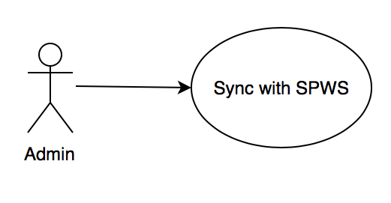

**Sequence Diagram**

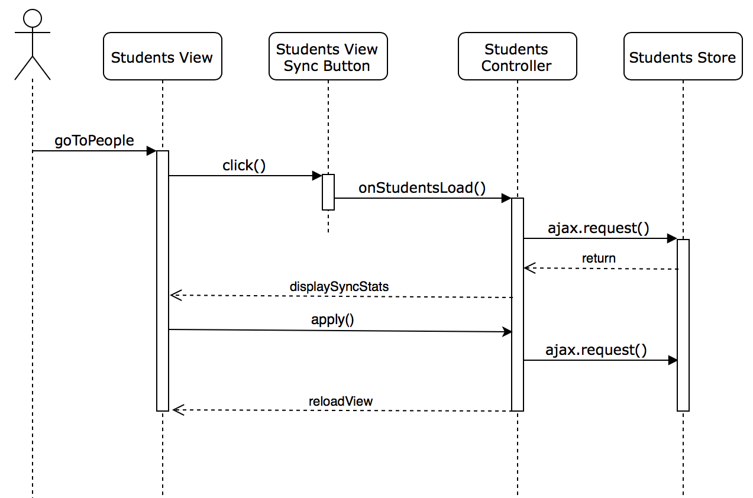

**Class Diagram**

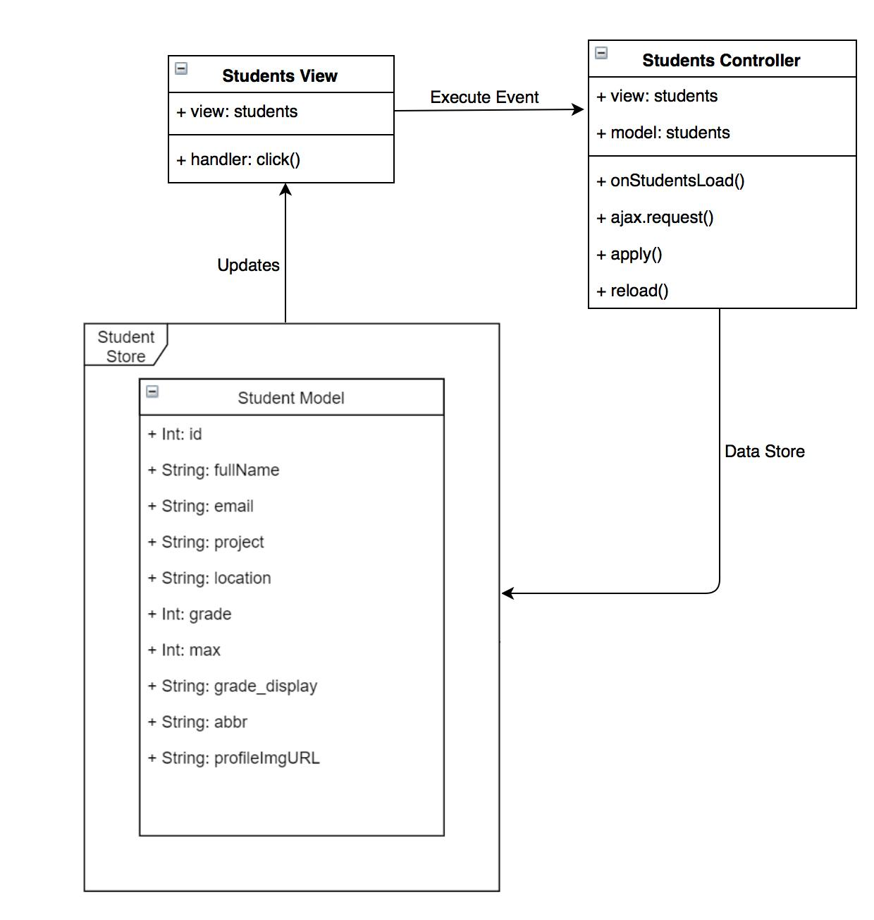

**Unit Test & Integration Test**

**Test case ID:** MJ-650-01

**Description/Summary of Test:** Sync and update all students record for current term

**Precondition:** Admin is logged in and currently viewing the students tab found in people side tab and has clicked on sync button.

**Expected Results:** Student’s records get updated except for the location field which stays the same.

**Actual Result:** All the student’s records got updated except for the location field which stayed the same.

**Status (Fail/Pass):** Pass

**Test case ID:** MJ-650-02

**Description/Summary of Test:** Sync and cancel the update of all students record for current term

**Precondition:** Admin is logged in and currently viewing the students tab found in people side tab and has clicked on sync button then clicks cancel.

**Expected Results:** Student’s records does not get updated

**Actual Result:** Student’s records did not get updated

**Status (Fail/Pass):** Pass

**Visual User Guide**

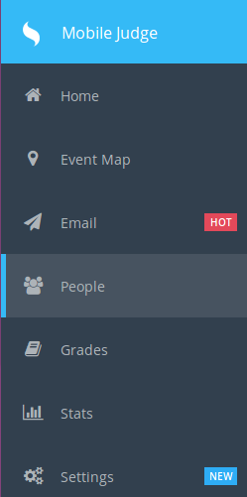 First go to the People tab on the left side of the screen.



Then in the students tab at the far right, the Sync button should be seen.

